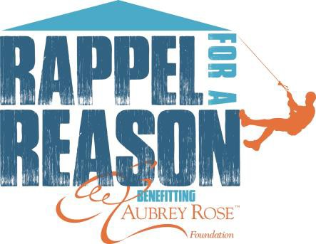

Hello Family and Friends,

I have signed up to do something that many of you may think is crazy! I will be participating in Rappel for a Reason benefitting the Aubrey Rose Foundation. Rappel for a Reason is much like it sounds. On Saturday, July 13th, I will stand on the roof of 36 E. 7th Street in downtown Cincinnati, Ohio and step Over the Edge and rappel 350 feet to the ground! I’m not making this up…check out the event website http://rappelforareason.com.

I am not asking you to rappel the building with me, but I will need your support to get to the top. I am not only pledging to Rappel for a Reason, but I am also committing to raise $1,000 for my “REASON” who is one of 75 critically ill children that needs the Aubrey Rose Foundation’s immediate help. The foundation’s mission is to provide a balanced giving program that will put huge smiles on the faces of medically-fragile children and their families. The work tirelessly to lift families from life’s complexities during unbelievably difficult times and provide emotional support & offer financial assistance with medical bills to families caring for children with life threatening conditions while maintaining a focus on the family unit.

How can you help? By making a 100% tax deductible donation to my website (insert your personal R4aR webpage address here) or by texting (insert your personal R4aR keyword here) to 71777.

You may also send checks or money orders made out to Aubrey Rose Foundation, 3862 Race Road, Cincinnati, Ohio 45211 (please make certain you note my name in the memo line.)

I thank you in advance for helping me support the great work that Aubrey Rose Foundation is doing. I promise to Rappel for a Reason in return for your kindness and generosity!

Sincerely,
(Your name here)

Rappel for a Reason benefitting the Aubrey Rose Foundation
rappelforareason@aubreyrose.org ♥ 3862 Race Road, Cincinnati, OH 45211 ♥ http://rappelforareason.com ♥ 513-728-2680

